CHANGING YOUR LIFE IN 2022
Immediate Upline name: Current Contract Level: FT/PT?
- WHERE DO I WANT TO BE IN 6 MONTHS? Business: Level of leadership, contract level, bank account, new agent: carrier kickers, SNA? (Below)

- PERSONALLY, WHERE DO I WANT TO BE IN 6 MONTHS?

- WHERE DO I WANT TO BE IN A YEAR? Business/Personally (same questions as above)

- TWO YEARS. Business/Personally

- WHERE DO I WANT TO BE IN 5 YEARS FROM NOW? Business/Personally

- WHAT E.A.R.S AM I GOING TO GET IN 2022? Producer avg issue $200k, Agency $500K
Why would this change my life? How much income would this potentially equate to?

- WHAT TRIPS AND AWARDS AM I GOING TO EARN FOR MY FAMILY IN 2022?
What do I need to focus on to make this a reality?

- LOOK BACK AT THE LIST ABOVE OF THESE 7 QUESTIONS AND ANSER, WHY DO I WANT THIS? HOW WOULD THIS CHANGE MY LIFE? -This is your vision. Look at it daily.

- WHAT AM I WILLING TO DO TO GET IT? What am I willing to give up to make this happen?

- WHAT STEPS DO I HAVE TO CHANGE NOW, TO MAKE THESE THINGS A REALITY? (List at least 3 top things). Ideas: Resources? Activity, Schedule, Sticking to the system? Commitment? Personal Growth?

- Share your vision! Share with your kids, spouse, parents, anyone you share your life with. Send to your AO, upline. Share your vision. Get their input and get them excited about your plan. You are all in this together!

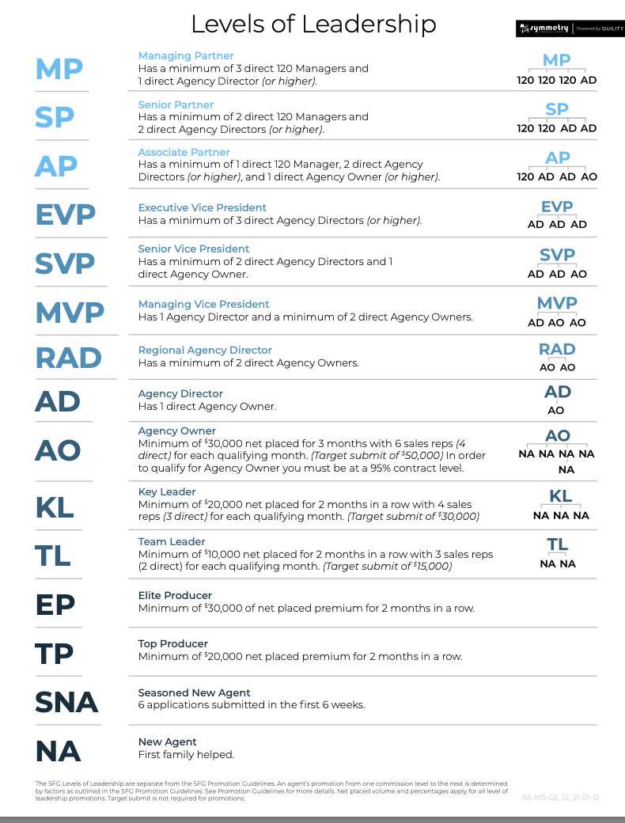

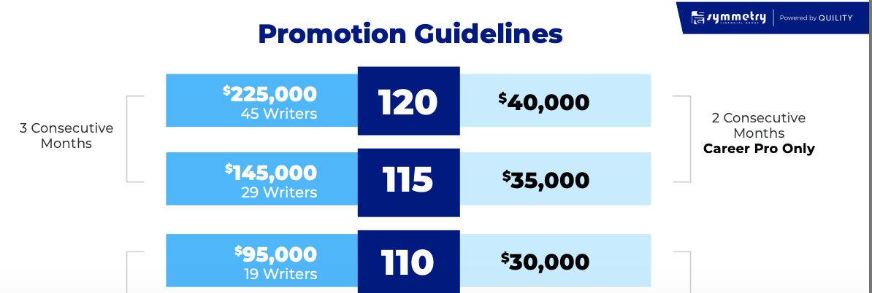
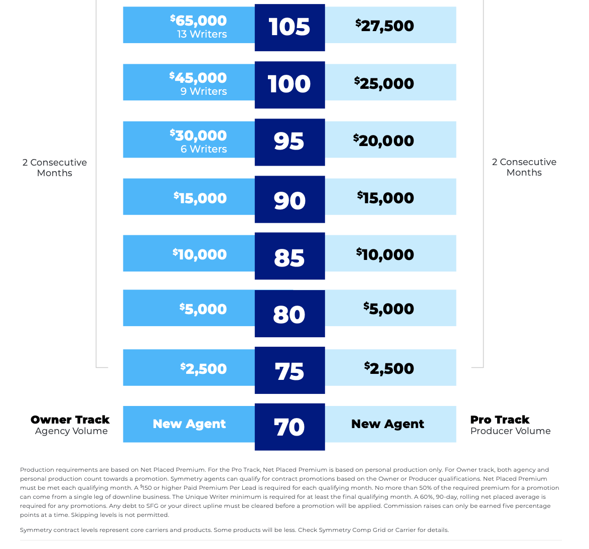
SLINGSHOT TO DENVER FOR CONTRACT LEVELS 70-80%