WEEKLY BUSINESS PLAN TEMPLATE
REPORT IN BY: Friday evening, Monday at the latest.
SEND TO: Your AO, Upline & miranda@mirandamartin.com
THIS PAST WEEK’S RESULTS:
- Immediate Upline name
- Leads Purchased (Type and Quantity of each):
- Dials Made (Goal vs Actual):
- Contacts Made:
- Appointments Set (Goal vs Actual):
- Presentations Made (Goal vs Actual):
- Families Helped:
- APV (Goal vs Actual):
- Are you full time or part time?
- How many QRS forms did you submit?
- Which dialer are you using? KIP NINJA
MONTHLY PRODUCTION STATUS:
- CURRENT MONTHLY APV GOAL: ACTUAL:
- TEAM BUILDERS: Team Monthly Goal: Team Actual:
- What is your income target to make this month?
- Are you eligible for the sling shot to Denver? (See details on next pg.)
  - Slingshot to Denver needs an app submitted 3 out of 4 weeks:
    - Did you submit an app:
      - week 1: Y/N week 2: Y/N week 3: Y/N week 4: Y/N
WEEKLY BUILDING:
- When is the next corporate overview?
- Goal is 10 on the next corp. overview. How are you doing towards that?
- Conf tix sold this week? Conf tix sold total?
- How much time did you spend building this week?
- Resources for building (type and amount)?
- Interview Count & Packets Back?

OVERALL
What went well:
What didn’t go so well:
How many/what recordings did you submit this week to your AO? (Appts booked, not interested, no shows, client presentation, recruiting interviews)

Plan to improve; what do you expect from yourself?

Anything we can do to help you?

NEXT WEEKS PLAN:
1.Lead Order:
2. Dials/Appts:
3. Presentations:
4. APV/Apps Submit/Issued:
6. QRS Forms Submit:
7. How many recordings will you submit this week?

(Next page are the promotion guidelines and slingshot to Denver details)

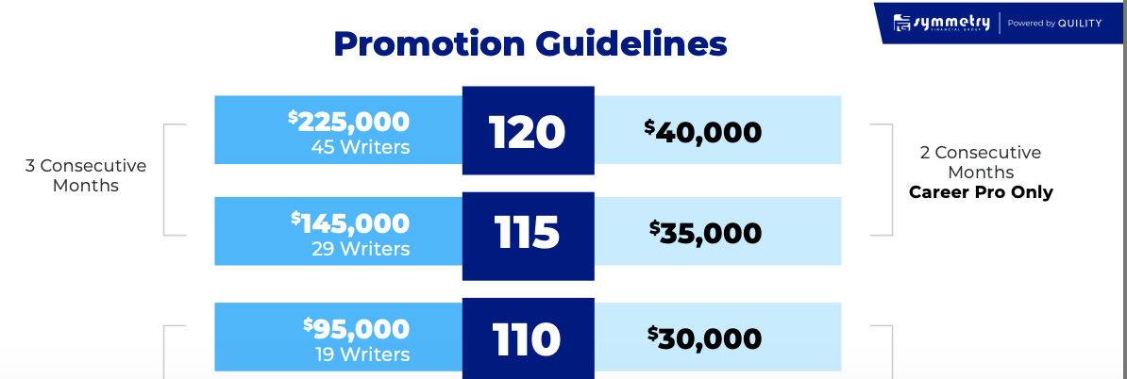
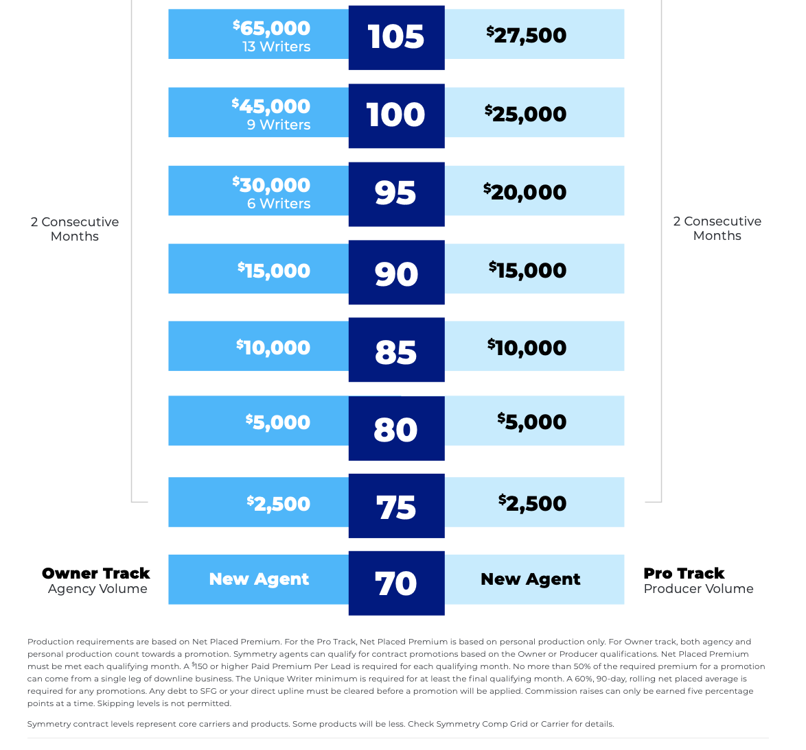

SLINGSHOT TO DENVER FOR CONTRACT LEVELS 70-80%