MONTHLY BUSINESS PLAN
Immediate Upline name: Current Contract Level: FT/PT?
MONTHLY APV TARGET:
INCOME PROJECTION:
WEEKLY BUDGET FOR LEADS: Gmr?
WEEKLY APPT COMMITMENT:
AGENCY BUILDING:
TEAM TARGET THIS MONTH:
MONTHLY BUDGET FOR BUILDING: Resources?
WEEKLY INTERVIEW COMMITMENT:
EVENTS:
- When is the next corporate overview?
- Goal is 10 on the next corp. overview. How are you doing towards that?
- Conf tix sold this week? Conf tix sold total?
OVERALL
What went well:
What didn’t go so well:

Action Plan:

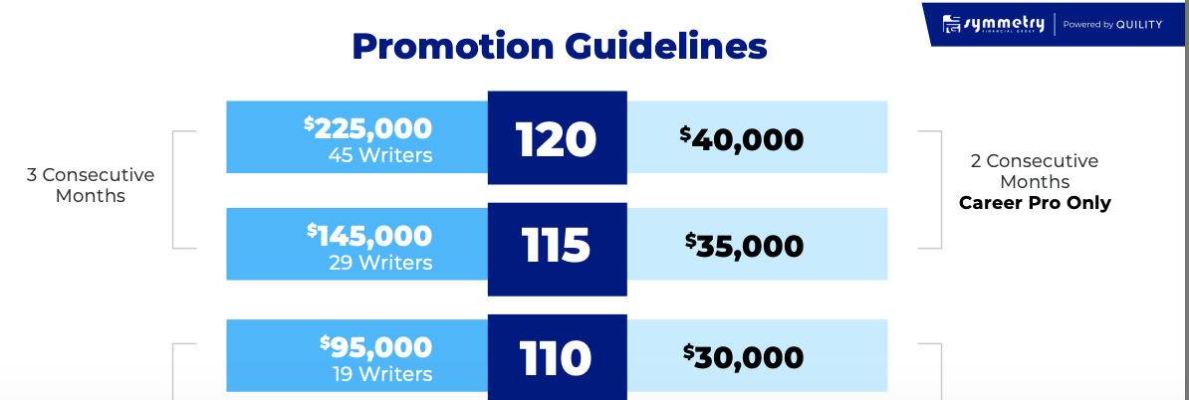
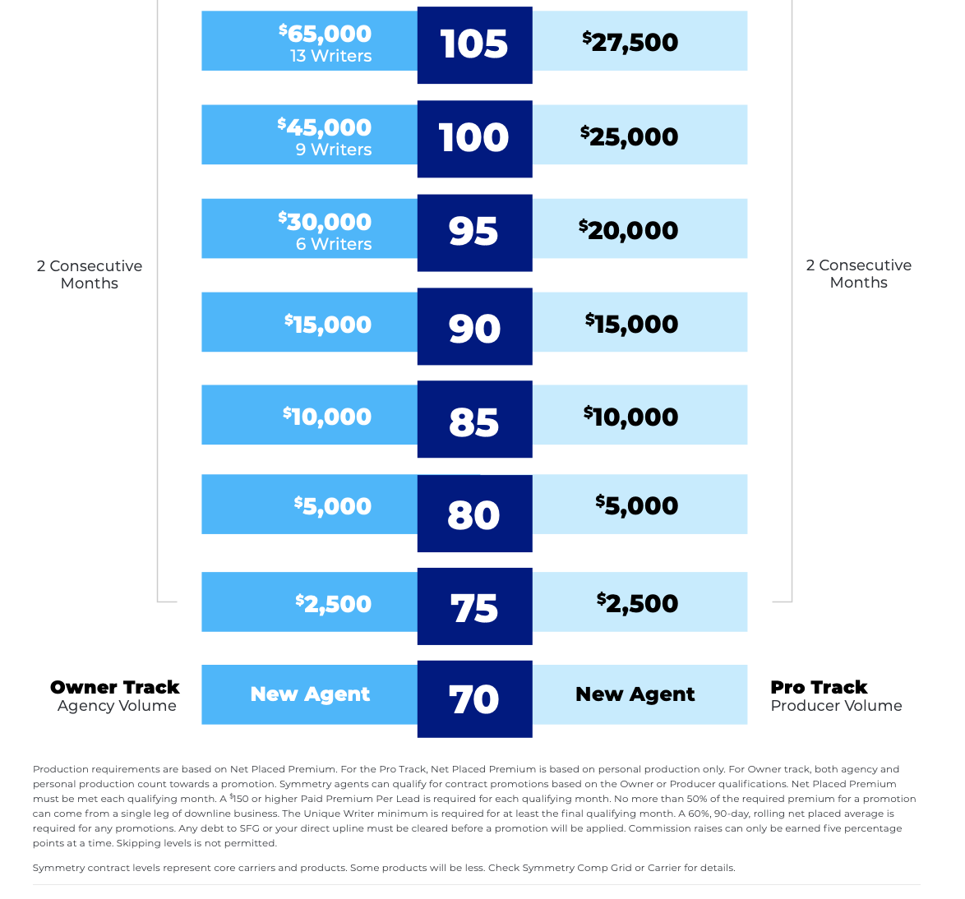

SLINGSHOT TO DENVER FOR CONTRACT LEVELS 70-80%