4 KEYS TO A SUCCESSFUL WEEK
Resources, Schedules, Activity, System
- Resources
- Full time 50-60 Bonus Leads per Week
- Full time with a GMR (10 A leads with 20-30 Bonus Leads)
- Part time 25-30 Bonus Leads per Week (With a GMR 5 A leads with 10-15 bonus leads)

Lead Expectations
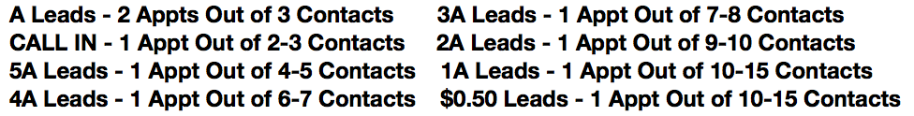
- Schedule
- “Failing to prepare is preparing to fail”
- Physically write out your schedule each week with these 7 things:
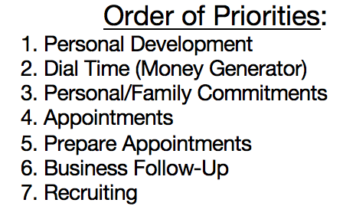
- Activity
- 35 Dials Per Hour
- 250-300 Dials Per Weekend
- Check in with Up-line: Every 5-10 Contacts when New
- Post Updates
- Hold Yourself Accountable

- System
Memorize Objections
- Role play Scripts
- Use 911 String In the Home
- B.E.S.T. System Phones
  - (Be busy, Establish why you are calling, Set appointments, Tie down)
- R.E.A.L. System In-Home (Rapport, Emotion, Assumption, Lock it down)

